Application Format for supply of School Bags for School Education Department, Government of West Bengal under Promotional Order

|  |  |  |  |
| --- | --- | --- | --- |
| Sl.No | Particulars | | Remarks |
| 1 | Name of the School Bag  manufacturer |  |  |
| 2 | Complete address of the School Bag manufacturing unit with name of contact person, phone number and email  address |  |  |
| 3 | Company Details – certificate of incorporation and MOA and AOA in case of Private/ Public Limited Company; copy of partnership deed; copy of certificate of incorporation and partnership deed in case of LLP; copy of proof of  Proprietorship firm. |  | Attach self attested copy |
| 4 | Registration No of the SSI/ MSME Unit |  | Attach self attested copy |
| 5 | PAN |  | Attach self attested copy |
| 6 | GST Registration No (if  applicable) |  | Attach self attested copy |
| 7 | Trade License Registration No |  | Attach self attested copy |
| 8 | Production Capacity per  month |  | Attach self attested copy |
| 9 | Turnover of last 5 Financial Years or from date of establishment, whichever is  less |  | Attach self attested copy |
| 10 | Name and Address of the Owner/ Partners with phone  number and email |  |  |

The above stated information is true to the best of my/ our knowledge and in case of any false information I/ we are liable to legal consequences and the order shall be cancelled.

Date: Name and Full Signature of the applicant with Seal

Note: Incomplete forms submitted will be rejected.

**Terms and Conditions**

* Applicants should submit application in the specified format only.
* The Applicants intending to obtain Promotional Order of School Bags for School Education Department, Government of West Bengal as per the approved reference samples and specifications at the approved rate of ₹ 99.00 per School Bag (including GST, carrying cost, delivery charges and any other charges) shall have to confirm the same by way of an affidavit.
* The Applicants must have the capability of producing School Bags, as per the approved reference samples and specifications of the School Education Department, Government of West Bengal given in the Schedule of Requirements.
* The Applicants should be a MSME/ SSI School Bag manufacturer having manufacturing unit in West Bengal.
* Inspection of the manufacturing unit, all documents will be done by the Departmental Committee and then allocation of quantity will be done.
* The Total Quantity to be procured under the Promotional Order is 3,53,620 (approximately).
* Departmental Committee will be making in person inspection of the manufacturing units to be satisfied on plant and machineries, production capacity and production quality. The quantity to be awarded shall be solely dependent on the production capacity and production quality as per the approved reference sample.
* **Awarded supply has to be completed within 26 February 2024.**
* The Competent Authority reserves the right to allocate remaining quantity amongst the participating bidders who agree to supply at L1 rate, in case any eligible units of promotional order fail to supply the entire quantity reserved for them
* Performance Security @3% of the order value is to be submitted to Biswa Bangla Marketing Corporation within 7 days of receipt of Work Order.
* If you fail to supply materials within the scheduled delivery dates, the authority of Biswa Bangla Marketing Corporation Limited reserves the right to cancel the supply order in full and forfeit the Performance Security Deposit.
* Completion Certificate stating quantity and value of similar school bag supplied by the Bidder in any of the last 3 Financial years (2020-21, 2021-22, 2022-23) if any.
* The Competent Authority with the approval of Departmental Tender Committee of MSME & Textiles Department, Government of West Bengal reserves the right to reject any or all application without assigning any reason whatsoever and would not be liable for any cost that might have been incurred by any Applicant.
* The last date of submission of application is **18 January 2024.**

**SECTION -III**

**SCHEDULE OF REQUIREMENTS (SOR)**

1. **FOREWORD**

The designs for school bags prescribed in the Schedule of Requirements has been developed primarily for school going boys & girls.

1. **SCOPE**

This standard prescribes the requirements, methods of sampling and tests for the school bags for boys and girls.

1. **TERMINOLOGY**

For the purpose of this standard, the definition given in IS 2050: 1967 shall apply.

1. **REQUIREMENTS**

|  |  |  |  |
| --- | --- | --- | --- |
| SL.  NO. | PROPERTY | UNIT | SPECIFICATION |
| **1** | **COLOUR** |  |  |
| 1.1 | COLOUR OF THE BAG |  | BLUE  (Any shade of visually pleasing BLUE. The bidder may submit specimen material of various shades of BLUE for prior approval of the department.) |
| 1.2 | COLOUR OF THE FRONT POCKET |  | BLUE  (Any shade of visually pleasing BLUE. The bidder may submit specimen material of various shades of BLUE for prior approval of the department.) |
| 1.3 | COLOUR OF THE SHOULDER STRIP |  | BLUE  (Any shade of visually pleasing BLUE. The bidder may submit specimen material of various shades of BLUE for prior approval of the department.) |
| 1.4 | COLOUR OF THE ADJUSTABLE BELT |  | BLACK |

**Page | 14**

|  |  |  |  |
| --- | --- | --- | --- |
| SL.  NO. | PROPERTY | UNIT | SPECIFICATION |
| 1.5 | COLOUR OF THE BEADINGS |  | BLACK |
| 1.6 | COLOUR OF THE SHOULDER ADJUSTABLE BUCKLE |  | BLACK |
| 1.7 | COLOUR OF THE WATER BOTTLE POCKET |  | BLACK |
| 1.8 | COLOUR OF THE ZIP |  | BLACK |
| 1.9 | COLOUR OF RUNNER |  | STEEL |
| 1.10 | COLOUR OF THE TOP HANDLE |  | BLUE  (Any shade of visually pleasing BLUE. The bidder may submit specimen material of various shades of BLUE for prior approval of the department.) |
| 2 | **DIMENSIONS** |  |  |
| 2.1 | MAIN COMPARTMENT |  |  |
|  | LENGTH (MIN) | mm | 440 |
|  | BREADTH (MIN) | mm | 300 at lower end and 260 at upper end. Tapered at top with rounded corners. |
|  | DEPTH (MIN) BORDER SIZE | mm | 150 |
| 2.2 | FRONT POCKET |  |  |
|  | LENGTH (TOP TO BOTTOM) | mm | 365 |
|  | BREADTH (RIGHT TO LEFT) | mm | 265 |

**Page | 15**

|  |  |  |  |
| --- | --- | --- | --- |
| SL.  NO. | PROPERTY | UNIT | SPECIFICATION |
|  | DEPTH (MIN) BORDER SIZE (TAKEN FROM BASE) | mm | 35 |
| 2.3 | SHOULDER STRAP |  |  |
|  | LENGTH (TOP TO BOTTOM) | mm | 425 |
|  | BREADTH (RIGHT TO LEFT) | mm | 55 |
|  | MATERIAL SPECIFICATION |  | Shoulder strap front side will be main polyester fabric and back side will be super fine heavy quality soft net. |
| 2.4 | WATER BOTTLE POCKET |  | On Both Side |
|  | LENGTH | mm | 200 |
|  | BREADTH | mm | 180 |
|  | MATERIAL SPECIFICATION |  | Knitted Polyester Yarn super fine heavy quality |
| **3** | **ZIP** |  |  |
| 3.1 | MAIN COMPARTMENT |  |  |
|  | LENGTH | mm | 500 |
|  | ZIP NO. | 8no. | 8no. |
| 3.2 | FRONT POCKET |  |  |
|  | LENGTH | mm | 450 |
|  | ZIP NO. | 8 no. | 8 no. |
| **4** | **RUNNER HANDLE** |  |  |
|  | LENGTH | mm | 35 |

**Page | 16**

|  |  |  |  |
| --- | --- | --- | --- |
| SL.  NO. | PROPERTY | UNIT | SPECIFICATION |
|  | WIDTH | mm | 10 |
| **5** | **TOP HANDLE** |  |  |
|  | LENGTH | mm | 150 min |
|  | WIDTH | mm | 40 min |
| **6** | **ADJUSTABLE BELT** |  |  |
|  | LENGTH | mm | 500 |
|  | BREADTH | mm | 25 |
|  | THICKNESS AND WEIGHT PER METER | g | Good quality of adequate strength. |
| 7 | **POCKET ELASTIC** |  | Good quality of adequate strength. |
| 8 | **MATERIAL SPECIFICATION** |  |  |
| 8.1 | OUTER LAYER |  | Polyester Bag fabric, with PVC coated (300 x 300 diem)  GSM 400 ± 20 |
| 8.2 | CUSHION FOAM |  | XLPE (Cross linked expandable polyethylene foam) of 6 mm thickness |
| 8.3 | ZIP |  | Polyethylene terephthalate (Pet.) 8no. Zip 100 yards=1.8 kg |
| 8.4 | NET |  | Knitted polyester fabric |
| 8.5 | ADJUSTABLE BELT |  | Polypropylene knitted fiber of good quality, Approximate  weight 12 ± 1 gm per meter |
| 8.6 | SHOULDER ADJUSTABLE BUCKLE |  | Polypropylene, should not break at 4kg f.minimum |

**Page | 17**

|  |  |  |  |
| --- | --- | --- | --- |
| SL.  NO. | PROPERTY | UNIT | SPECIFICATION |
|  |  |  | Impact |
| 8.7 | THREAD |  | Polyester spun yarn TKT 30 |
| 8.8 | MAIN FABRIC BODY | BS  WARP | 50 KGS |
|  |  | BS  WEFT | 30 KGS |
|  |  | TR  WARP | 4 KGS |
|  |  | TR  WEFT | 5 KGS |
| 8.10 | TEST | Drop Test | Should not fail at 10 kg. |
| 8.11 | NO. OF STITCHES |  | 6-9 STITCHES PER 25MM OF STITCH LENGTH |
| 8.12 | LINING MATERIAL |  | Weight of the lining material will be approximately 60 ± 5 GSM (190T) |

**Shape and Design**

The bags shall be made to the pattern, shape and design as shown in the photographs or images which will be provided at the Pre-bid meeting and publicised on the websites https://wbtenders.gov.in and [www.biswabangla.in.](http://www.biswabangla.in/)

**MANUFACTURING, WORKMANSHIP AND FINISH**

The school bag shall be made from three pieces of material, that is, front, back and gusset.

The front portion shall be such as to provide sufficient space for keeping lunchbox, pencil box, instrument box etc.

The bag shall be provided of all seams with plastic piping and self-material including the pocket, top edge sand the sides as shown in the diagram.

**Page | 18**

The school bag shall be assembled ‘lockstitch ‘or ‘chainstitch’ regulated to give 6 to 8 stitches per 25 mm. All ends shall be securely fastened, off and loose threads properly trimmed.

Two buckles with straps shall be provided in the bag for closure as shown in the diagram.

The bag shall be neatly finished with straight and parallel rows of stitching, where required.

The ends of buckles loops, side back and buckle straps shall be properly tacked with the rows of stitches as shown in the diagram.

Thread to be used: Spun polyester TKT30.

Adjustable strip be stitched along center bottom. Specification of bag shoulder not mentioned should be 300 X 300 diem. Both side polyester fabric, with PU/PVC coated and inside 6 mm foam.

Packing specification: 50 bags in one carton.

One sample bag can be inspected at the office of the Corporation at Karigari Bhawan, Room No 009, Ground Floor, Plot B/7, Action Area III, New Town, Rajarhat, Kolkata – 700160.

**TESTS:-**

**Drop Test –T**he school bag shall be fully loaded with books or suitable materials weighing 10 kgs. After filling the specified weight, the bags shall be closed, fastened and hung on pegs at the wall with the help of the back strap. The distance between the floor and the peg shall be 1.0 meter in back strap. The bags shall then be suddenly dropped, and this operation shall be repeated ten times. During or after the test the stitches shall not open, the straps and buckles shall not give way or come off the stitched tacks.

**Snatch Test –**The school bag shall be securely fixed in an inverted position on a rigid support, leaving the strap free for applying the load. The strap shall be suitably harnessed to distribute the load applied over the entire middle portion. A load of 50 N (5 Kg) shall be applied suddenly to the strap for a period of 30 seconds. This operation shall be repeated 10times.

The weight may be applied either by means of spring balance or weight suitably placed on a stirrup. During or after the test, the strap shall not have snapped, loosened or come off the stitching.

**Page | 19**

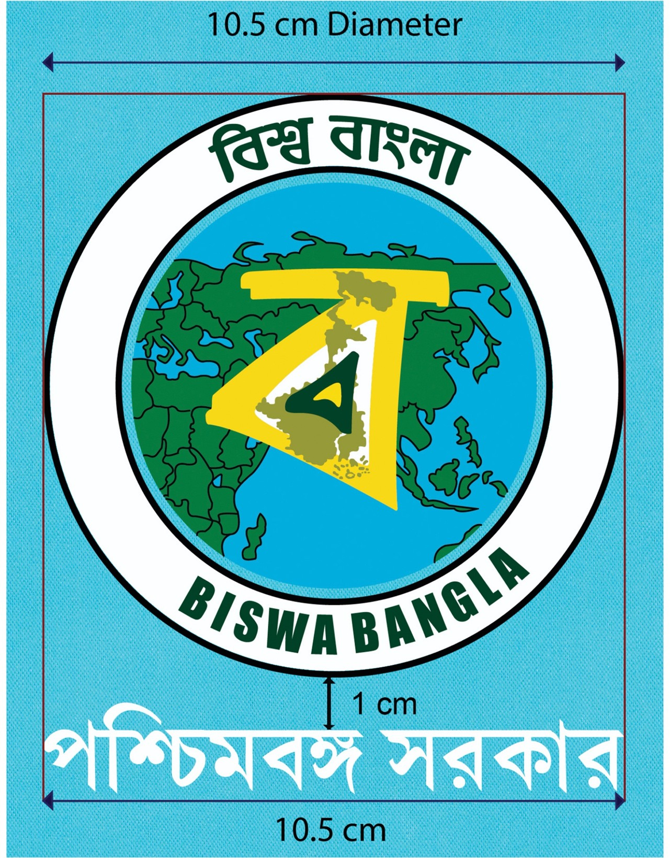

**LOGO TO BE PRINTED ON THE SCHOOL BAG**

**IMPORTANT NOTE:** THE ABOVE PICTURE/ IMAGE MAY NOT REVEAL THE TRUE COLOURS/ SHADES AND THE EXACT TONE, AND ALSO THE LOOK AND FEEL OF THE REFERENCE SAMPLE OF THE BAG AS APPROVED BY THE COMPETENT AUTHORITY IN THE GOVERNMENT OF WEST BENGAL.

THE SAMPLES SUBMITTED BY THE BIDDERS ALONG WITH THE TECHNICAL BIDS, AND ALSO THE BAGS WHICH WILL BE FINALLY MANUFACTURED AND DELIVERED SHALL/ MUST MATCH (INCLUDING THE COLOURS/ SHADES AND TONES OF THE FABRIC, THAT OF THE LOGO, ETC.) WITH THE **APPROVED REFERENCE SAMPLE OF THE BAG** THAT HAS BEEN **KEPT ON PUBLIC DISPLAY** AT THE OFFICE OF BISWA BANGLA MARKETING CORPORATION AT KARIGARI BHAWAN, ROOM NO. 009, B/7, ACTION AREA III, RAJARHAT, NEW TOWN, KOLKATA 700160.

**SWATCH** OF THE APPROVED REFERENCE SAMPLE OF **FABRIC** MAY BE COLLECTED FROM THE SAME OFFICE.

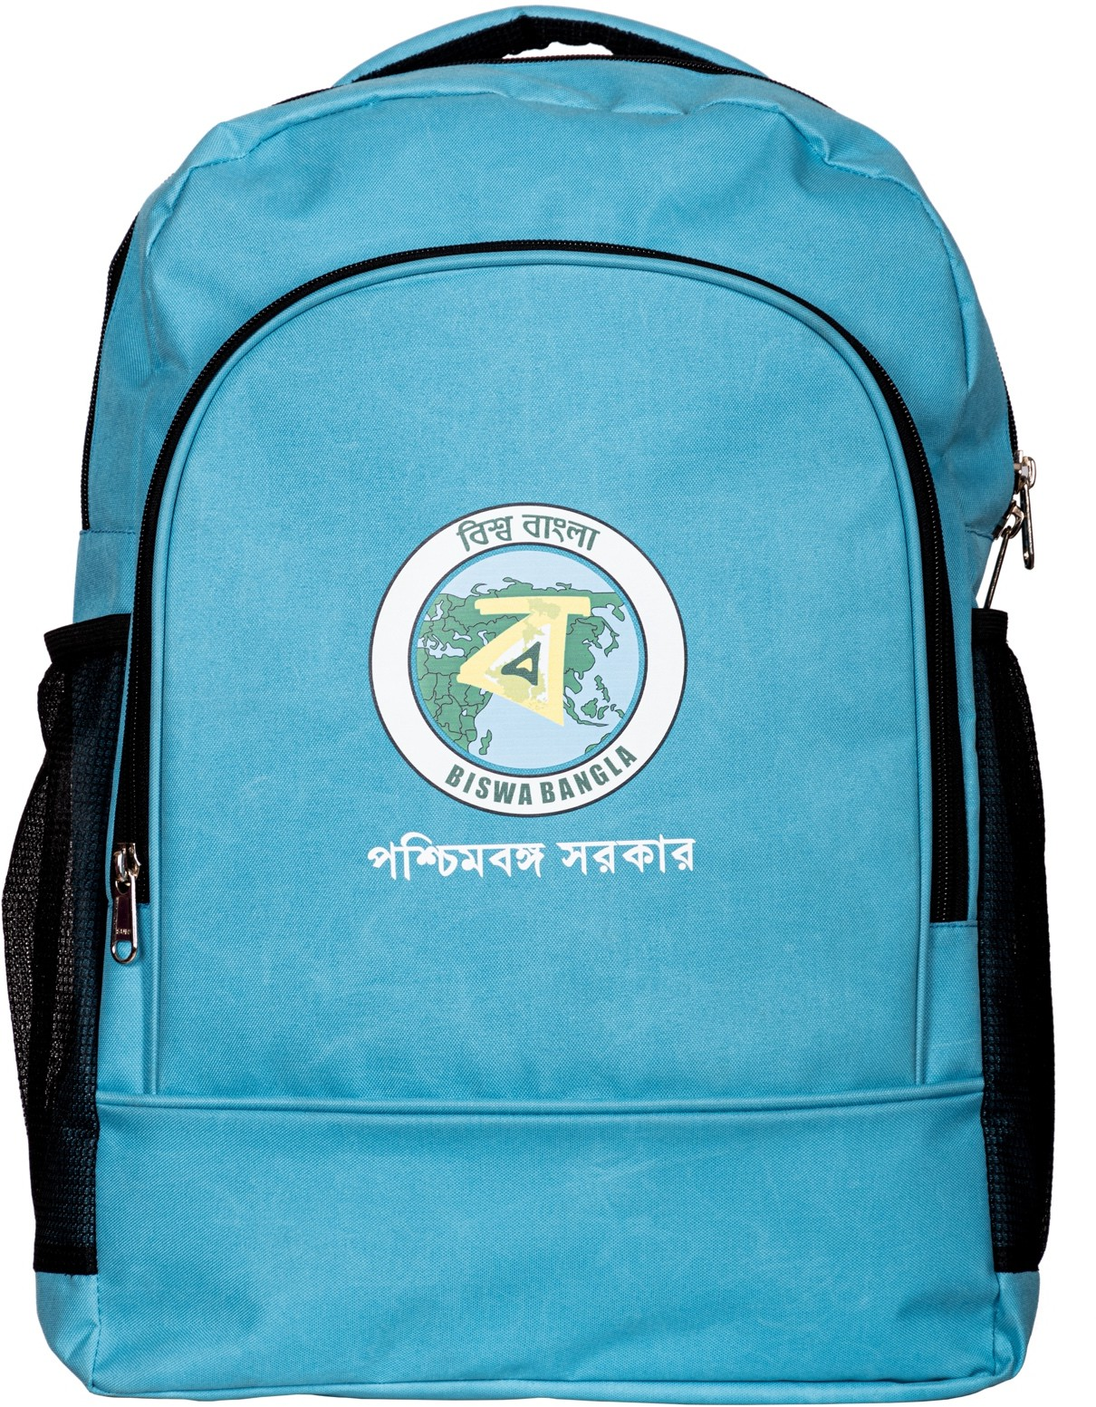

# FRONT VIEW

**IMPORTANT NOTE:** THE ABOVE PICTURE/ IMAGE MAY NOT REVEAL THE TRUE COLOURS/ SHADES AND THE EXACT TONE, AND ALSO THE LOOK AND FEEL OF THE REFERENCE SAMPLE OF THE BAG AS APPROVED BY THE COMPETENT AUTHORITY IN THE GOVERNMENT OF WEST BENGAL.

THE SAMPLES SUBMITTED BY THE BIDDERS ALONG WITH THE TECHNICAL BIDS, AND ALSO THE BAGS WHICH WILL BE FINALLY MANUFACTURED AND DELIVERED SHALL/ MUST MATCH (INCLUDING THE COLOURS/ SHADES AND TONES OF THE FABRIC, THAT OF THE LOGO, ETC.) WITH THE **APPROVED REFERENCE SAMPLE OF THE BAG** THAT HAS BEEN **KEPT ON PUBLIC DISPLAY** AT THE OFFICE OF BISWA BANGLA MARKETING CORPORATION AT KARIGARI BHAWAN, ROOM NO. 009, B/7, ACTION AREA III, RAJARHAT, NEW TOWN, KOLKATA 700160.

**SWATCH** OF THE APPROVED REFERENCE SAMPLE OF **FABRIC** MAY BE COLLECTED FROM THE SAME OFFICE.

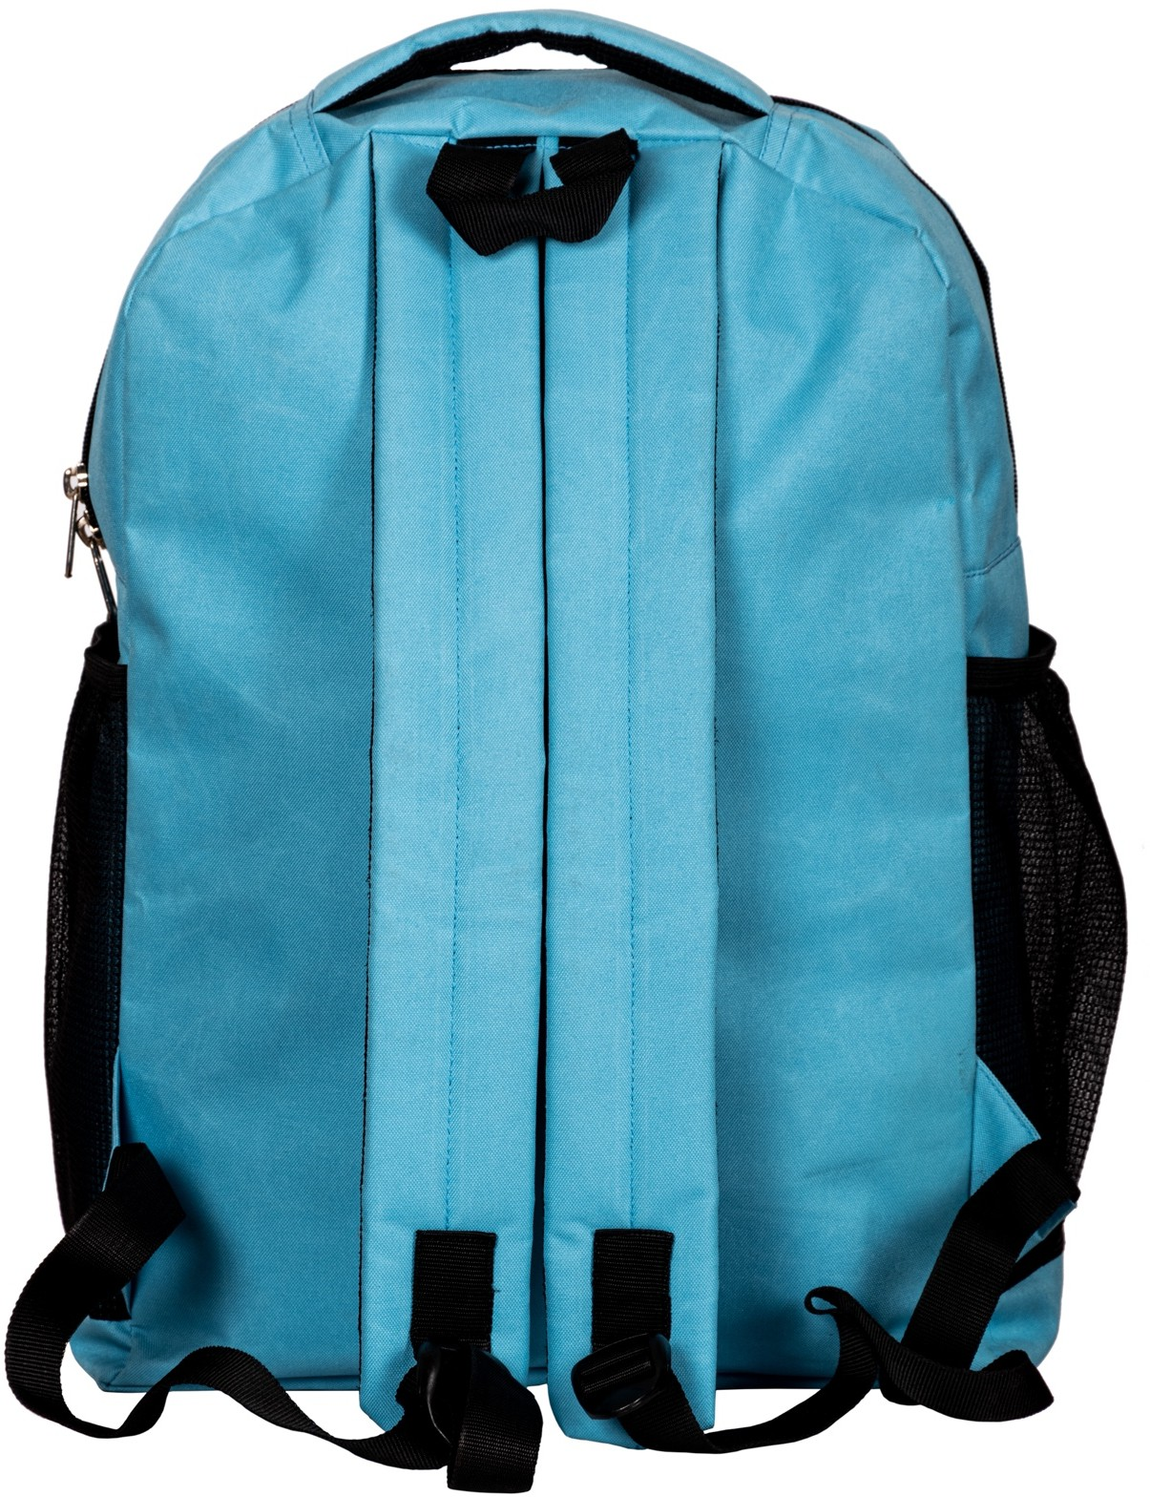

# REAR VIEW

**IMPORTANT NOTE:** THE ABOVE PICTURE/ IMAGE MAY NOT REVEAL THE TRUE COLOURS/ SHADES AND THE EXACT TONE, AND ALSO THE LOOK AND FEEL OF THE REFERENCE SAMPLE OF THE BAG AS APPROVED BY THE COMPETENT AUTHORITY IN THE GOVERNMENT OF WEST BENGAL.

THE SAMPLES SUBMITTED BY THE BIDDERS ALONG WITH THE TECHNICAL BIDS, AND ALSO THE BAGS WHICH WILL BE FINALLY MANUFACTURED AND DELIVERED SHALL/ MUST MATCH (INCLUDING THE COLOURS/ SHADES AND TONES OF THE FABRIC, THAT OF THE LOGO, ETC.) WITH THE **APPROVED REFERENCE SAMPLE OF THE BAG** THAT HAS BEEN **KEPT ON PUBLIC DISPLAY** AT THE OFFICE OF BISWA BANGLA MARKETING CORPORATION AT KARIGARI BHAWAN, ROOM NO. 009, B/7, ACTION AREA III, RAJARHAT, NEW TOWN, KOLKATA 700160.

**SWATCH** OF THE APPROVED REFERENCE SAMPLE OF **FABRIC** MAY BE COLLECTED FROM THE SAME OFFICE.

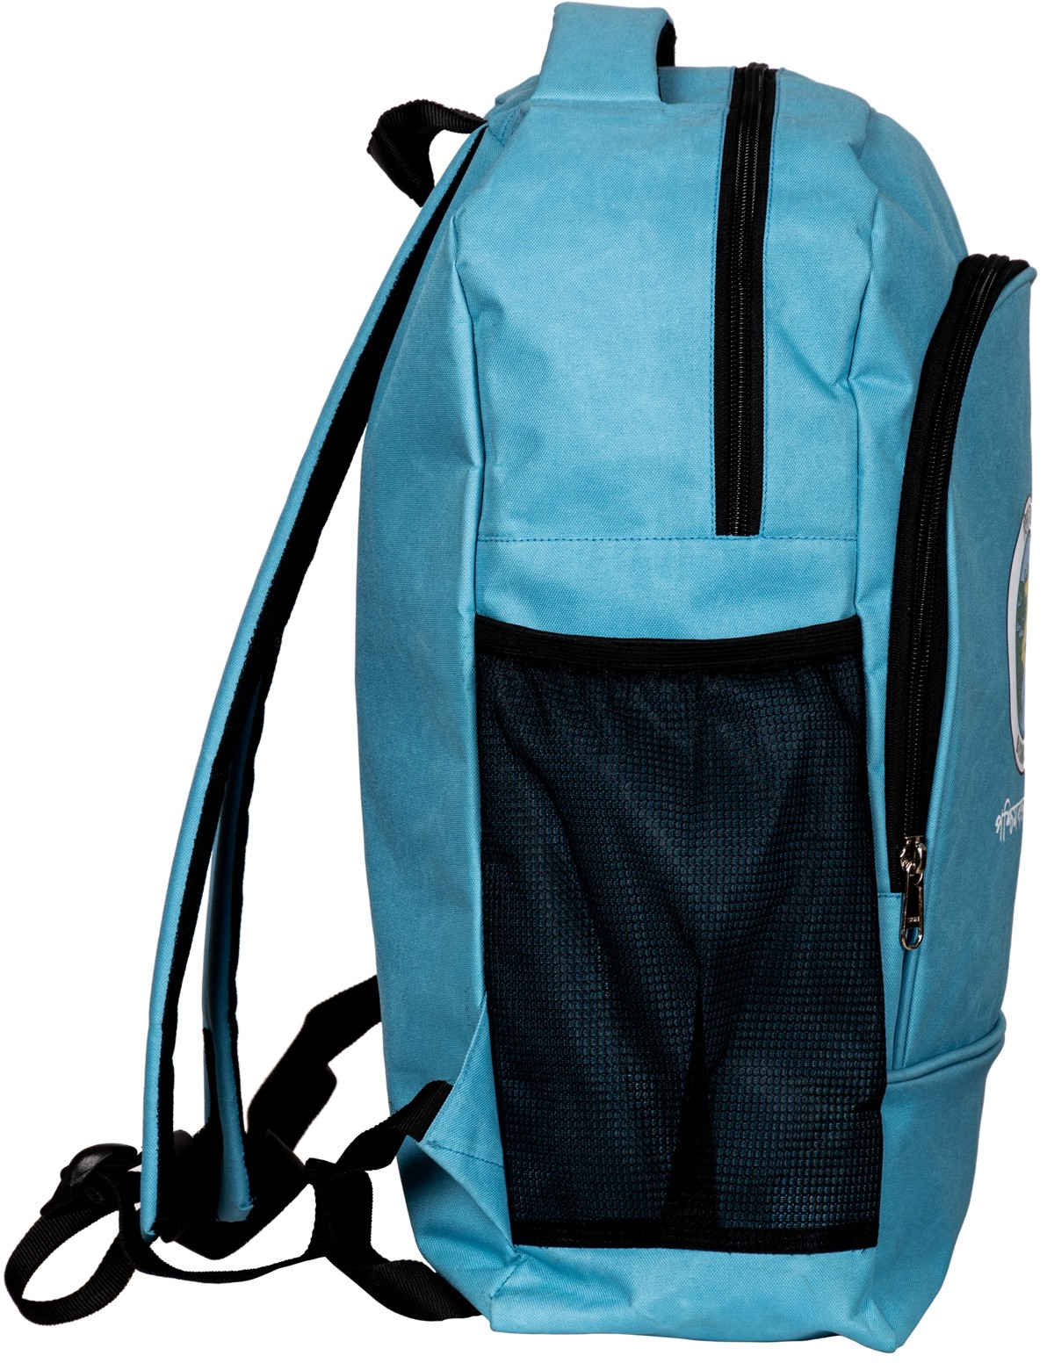

# SIDE VIEW - 1

**IMPORTANT NOTE:** THE ABOVE PICTURE/ IMAGE MAY NOT REVEAL THE TRUE COLOURS/ SHADES AND THE EXACT TONE, AND ALSO THE LOOK AND FEEL OF THE REFERENCE SAMPLE OF THE BAG AS APPROVED BY THE COMPETENT AUTHORITY IN THE GOVERNMENT OF WEST BENGAL.

THE SAMPLES SUBMITTED BY THE BIDDERS ALONG WITH THE TECHNICAL BIDS, AND ALSO THE BAGS WHICH WILL BE FINALLY MANUFACTURED AND DELIVERED SHALL/ MUST MATCH (INCLUDING THE COLOURS/ SHADES AND TONES OF THE FABRIC, THAT OF THE LOGO, ETC.) WITH THE **APPROVED REFERENCE SAMPLE OF THE BAG** THAT HAS BEEN **KEPT ON PUBLIC DISPLAY** AT THE OFFICE OF BISWA BANGLA MARKETING CORPORATION AT KARIGARI BHAWAN, ROOM NO. 009, B/7, ACTION AREA III, RAJARHAT, NEW TOWN, KOLKATA 700160.

**SWATCH** OF THE APPROVED REFERENCE SAMPLE OF **FABRIC** MAY BE COLLECTED FROM THE SAME OFFICE.

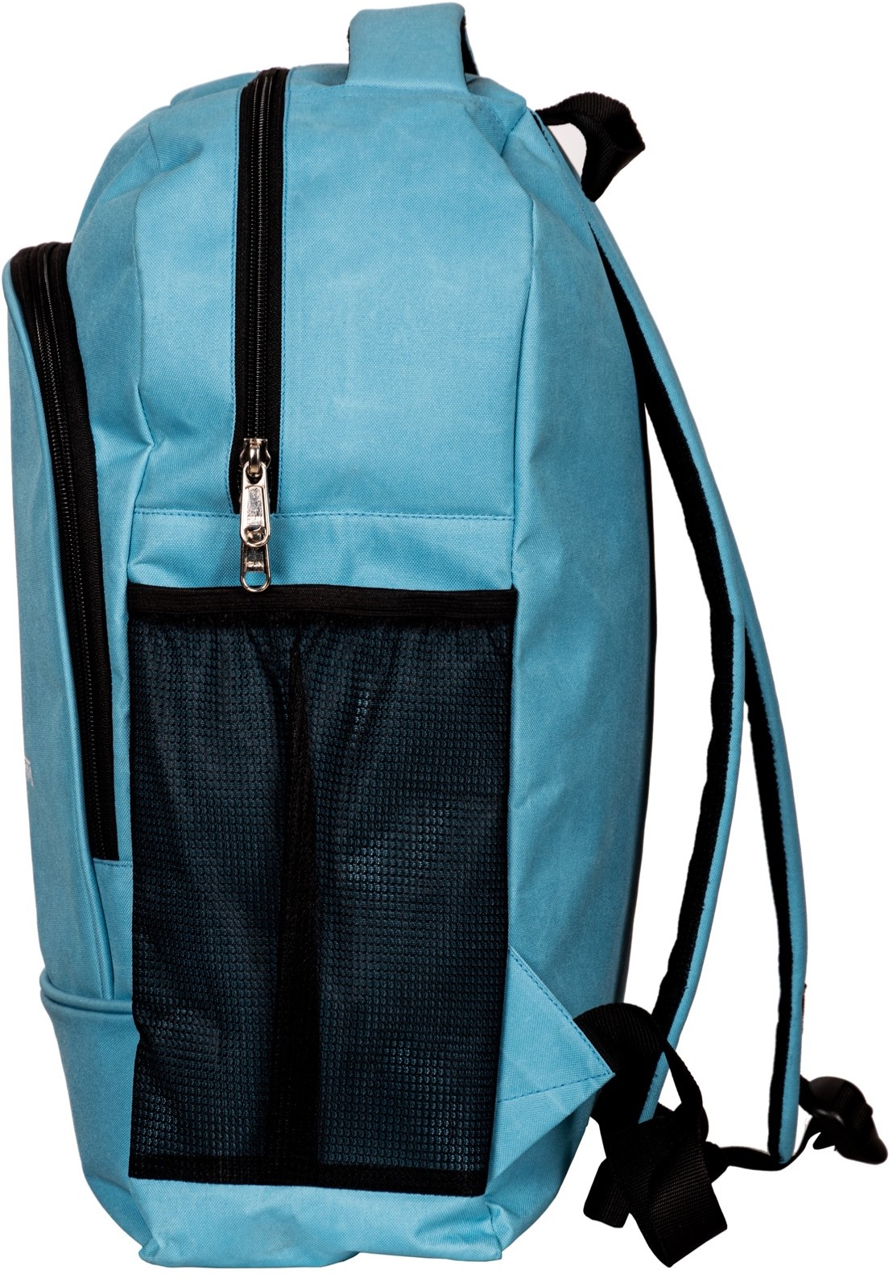

# SIDE VIEW - 2

**IMPORTANT NOTE:** THE ABOVE PICTURE/ IMAGE MAY NOT REVEAL THE TRUE COLOURS/ SHADES AND THE EXACT TONE, AND ALSO THE LOOK AND FEEL OF THE REFERENCE SAMPLE OF THE BAG AS APPROVED BY THE COMPETENT AUTHORITY IN THE GOVERNMENT OF WEST BENGAL.

THE SAMPLES SUBMITTED BY THE BIDDERS ALONG WITH THE TECHNICAL BIDS, AND ALSO THE BAGS WHICH WILL BE FINALLY MANUFACTURED AND DELIVERED SHALL/ MUST MATCH (INCLUDING THE COLOURS/ SHADES AND TONES OF THE FABRIC, THAT OF THE LOGO, ETC.) WITH THE **APPROVED REFERENCE SAMPLE OF THE BAG** THAT HAS BEEN **KEPT ON PUBLIC DISPLAY** AT THE OFFICE OF BISWA BANGLA MARKETING CORPORATION AT KARIGARI BHAWAN, ROOM NO. 009, B/7, ACTION AREA III, RAJARHAT, NEW TOWN, KOLKATA 700160.

**SWATCH** OF THE APPROVED REFERENCE SAMPLE OF **FABRIC** MAY BE COLLECTED FROM THE SAME OFFICE.